Connect SoCal 2024 - Community Partner Toolkit
[Embargoed – please hold until 11.2.23]

No. | Item | Content
1 | Personal Invitation Email: Agency  Please distribute to colleagues at cities, counties and other relevant agencies. | [SUBJECT: Connect SoCal 2024 Draft is Available for Comment]  Every four years, the Southern California Association of Governments (SCAG) updates Connect SoCal, Southern California’s Regional Transportation Plan/Sustainable Communities Strategy for the six-county region—as required by federal and state regulations. The draft Connect SoCal 2024 plan is now available for public review and comment through Jan. 12, 2024.  The draft Connect SoCal 2024 outlines a vision for a more resilient and equitable future, with policies and strategies for achieving the region’s shared goals through 2050. The plan was developed through a four-year planning process involving rigorous technical analysis, extensive stakeholder engagement and robust policy discussions with local elected leaders.  The Plan includes:  - $750 billion in transportation projects and a regional development pattern that creates transportation efficiencies  - Strategies for developing housing closer to jobs and daily needs, addressing homelessness and making housing more affordable  - Strategies for targeted investment in underserved communities  Watch a short video to learn more about Connect SoCal 2024: https://youtu.be/KIo23LsMv3k.  During the comment period, SCAG staff will conduct briefings in each county for elected leaders to discuss and provide input on the draft Plan. Agencies and members of the public are invited to attend public hearings to learn more about the contents of the Plan, ask questions and provide comments at a public hearing:  Public Hearings:  Dec. 4, 2023 | 4-6 p.m.  SCAG Los Angeles Office*  900 Wilshire Blvd., Ste. 1700  Los Angeles, CA 90017  Streaming link: scag.ca.gov/connectsocal-zoom  Dec. 5, 2023 | 2-4 p.m.  SCAG Los Angeles Office*  900 Wilshire Blvd., Ste. 1700  Los Angeles, CA 90017  Streaming link: scag.ca.gov/connectsocal-zoom  Dec. 8, 2023 | 10 a.m.-noon  SCAG Los Angeles Office*  900 Wilshire Blvd., Ste. 1700  Los Angeles, CA 90017  Streaming link: scag.ca.gov/connectsocal-zoom  *Alternatively, the public is invited to attend a telecast at any of SCAG’s regional offices; please see the list here.  Comments can be submitted via any of the following methods:  - SCAG’s online comment system: https://scag.ca.gov/connect-socal-comments  - Email: ConnectSoCal@scag.ca.gov  - U.S. Postal Service (must be postmarked on or before Jan. 12, 2024):  Draft Connect SoCal Plan Comments  Attn: Connect SoCal Team  Southern California Association of Governments  900 Wilshire Blvd., Ste. 1700  Los Angeles, CA 90017  SCAG staff will catalogue and consider all public comments, documenting any resulting revisions between the draft and final versions of Connect SoCal 2024. A record of those comments and responses can be found in the Final Public Participation and Consultation Technical Report.  Connect SoCal 2024 Draft Program Environmental Impact Report  SCAG, as the California Environmental Quality Act (CEQA) Lead Agency, has released a Draft Program Environmental Impact Report (Draft PEIR) (State Clearinghouse No.: 2022100337) for the proposed 2024-2050 Regional Transportation Plan and Sustainable Communities Strategy (RTP/SCS), also referred to as “Connect SoCal 2024”, “2024 RTP/SCS”, “Plan” or “Project.” The Draft PEIR serves as a programmatic document that presents a regionwide assessment of the potential environmental effects of Connect SoCal 2024.  A copy of the Notice of Availability (NOA) and Connect SoCal 2024 Draft PEIR is available by visiting scag.ca.gov/peir.  SCAG is scheduled to begin a 65-day CEQA public review and comment period for the Draft PEIR beginning Nov. 9, 2023. Written comments will be accepted no later than 5:00 p.m. on Jan. 12, 2024 (PST).  Email: ConnectSoCalPEIR@scag.ca.gov  Mail:  Attn: Karen Calderon  900 Wilshire Blvd., Ste. 1700, Los Angeles, CA 90017  U.S. Postal Service (must be postmarked on or before Jan. 12, 2024)  SCAG is primarily using electronic mail to notify interested parties. In accordance with the Americans with Disabilities Act and Language Accessibility, SCAG is committed to helping those with disability and/or with limited proficiency in the English language access the agency’s essential public information and services in accordance with Title VI of the Civil Rights Act.  Please contact Karen Calderon at ConnectSoCalPEIR@scag.ca.gov or (213) 236-1983 to request accommodation or if you need additional information, would like to receive future CEQA notices or request hard copies. SCAG will respond within 72 hours of an accommodation request and will make every effort to arrange for assistance as soon as possible.  NOTE: This is a separate, but parallel, comment period to the one for the Draft Connect SoCal 2024 regional plan, which ends on the same date.  Want to learn more?  Stay up to date with the Connect SoCal plan at ConnectSoCal.org.  Or contact your local Government Affairs Officer at:  Yahaira Ortiz  Government Affairs Officer  Phone: (213) 630-1548  Email: ortiz@scag.ca.gov
2 | Example of Email/Web/newsletter SHORT version for other counties | [SUBJECT: Regional Plan Update Now Available for Public Comment]  Dear [NAME]:  Every four years, the Southern California Association of Governments (SCAG) updates Connect SoCal, its long-term plan for the future of the region. Connect SoCal 2024 outlines strategies across the areas of mobility, communities, environment and economy to navigate to a more equitable resilient future and achieve our region’s shared goals.  Watch a short video to learn more about Connect SoCal 2024: https://youtu.be/KIo23LsMv3k.  The draft Connect SoCal 2024 plan is available for public review and comment, now through Jan. 12, 2024. Please attend a public hearing to learn more and give your input:  Public Hearings:  Dec. 4, 2023 | 4-6 p.m.  SCAG Los Angeles Office*  900 Wilshire Blvd., Ste. 1700  Los Angeles, CA 90017  Streaming link: scag.ca.gov/connectsocal-zoom  Dec. 5, 2023 | 2-4 p.m.  SCAG Los Angeles Office*  900 Wilshire Blvd., Ste. 1700  Los Angeles, CA 90017  Streaming link: scag.ca.gov/connectsocal-zoom  Dec. 8, 2023 | 10 a.m.-noon  SCAG Los Angeles Office*  900 Wilshire Blvd., Ste. 1700  Los Angeles, CA 90017  Streaming link: scag.ca.gov/connectsocal-zoom  * For your convenience, all Connect SoCal public hearings will be telecast at the SCAG Orange County office located at, 600 S. Main St., Ste. 1143, Orange, CA 92868.  For more information, please visit https://www.connectsocal.org.  Sincerely,  [YOUR NAME HERE]
3 | Website Post / E-newsletter article – LONGER version  The website post/e-newsletter article is geared more to the public audience. | Regional Plan Update Now Available for Review  Every four years, the Southern California Association of Governments (SCAG) updates Connect SoCal, its long-term plan for the future of the region. Connect SoCal 2024 outlines strategies across the areas of mobility, communities, environment and economy to navigate to a more equitable, resilient future and achieve our region’s shared goals.  The draft Connect SoCal 2024 plan is available for public review and comment, now until Jan. 12, 2024.  The draft Connect SoCal 2024 plan includes strategies for integrated transportation and land use planning—as shifting economic and demographic trends, climate change and technological advancements continue to transform the region.  The Plan includes:  - $750 billion in transportation projects and a regional development pattern that creates transportation efficiencies  - Strategies for developing housing closer to jobs and daily needs, addressing homelessness and making housing more affordable  - Strategies for targeted investment in underserved communities  The release of the draft Connect SoCal 2024 plan follows months of engagement with the public, elected officials and business leaders, as well as planners and other staff in the 191 jurisdictions in the SCAG region.  Watch a short video to learn more about Connect SoCal 2024:  https://youtu.be/KIo23LsMv3k.  Want to learn more? Please attend a public hearing at any SCAG office, or participate online:  Public Hearings:  Dec. 4, 2023 | 4-6 p.m.  SCAG Los Angeles Office*  900 Wilshire Blvd., Ste. 1700  Los Angeles, CA 90017  Streaming link: scag.ca.gov/connectsocal-zoom  Dec. 5, 2023 | 2-4 p.m.  SCAG Los Angeles Office*  900 Wilshire Blvd., Ste. 1700  Los Angeles, CA 90017  Streaming link: scag.ca.gov/connectsocal-zoom  Dec. 8, 2023 | 10 a.m. - noon  SCAG Los Angeles Office*  900 Wilshire Blvd., Ste. 1700  Los Angeles, CA 90017  Streaming link: scag.ca.gov/connectsocal-zoom  *Alternatively, the public is invited to attend a telecast at any of SCAG’s regional offices; please see the list here.  For more information, please visit https://www.connectsocal.org.
4 | Facebook/Instagram/ Nextdoor Post – longer version  You may adapt these according to your needs, but please tag SCAG by typing “@SCAG” and selecting “Southern California Association of Governments (SCAG)” from the list of options that appear. | Regional Plan Updated  Every four years, the Southern California Association of Governments (SCAG) updates Connect SoCal, its long-term plan for the future of the region. Connect SoCal 2024 outlines strategies across the areas of mobility, communities, environment and economy to navigate to a more equitable, resilient future and achieve our region’s shared goals.  Watch a short video to learn more about Connect SoCal 2024: https://youtu.be/KIo23LsMv3k.  The draft Connect SoCal 2024 plan is available for public review and comment, now through Jan. 12, 2024. Please attend a public hearing to learn more and give your input, Dec. 4-8. Please visit https://www.connectsocal.org for more information and to view the hearing schedule.  #equity #resiliency #mobility #housing #economy #environment #community
5 | Facebook/Instagram/ Nextdoor Post – short version | The latest regional plan update is now available! Check out this short video at https://youtu.be/KIo23LsMv3k to learn more. Attend a hearing Dec. 4, 5 or 8 to learn more about plans for Southern California between now and 2050. Visit ConnectSoCal.org to learn more.  #equity #resiliency #mobility #housing #economy #environment #community
6 | Twitter Post | @scagnews has released the latest draft regional plan update. Attend a hearing Dec. 4-8 to learn more about this visionary long-term plan for the region. Visit connectsocal.org. #equity #resiliency #mobility #housing #economy #environment #community

Graphics and Download Links

Content Type | Image | Size - pixels | Download Link
Square Graphic for Facebook/Instagram/ NextDoor post, website, e-newsletter | 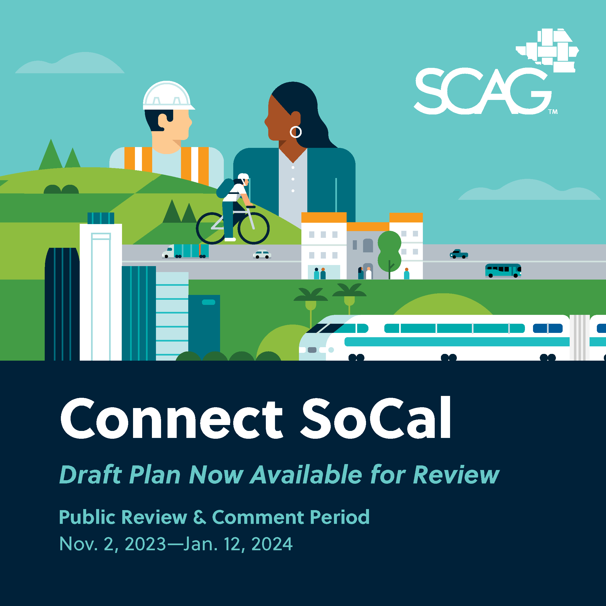 | 1080px x 1080px | Dropbox: General Square Graphic
Landscape Graphic for social media, website, e-newsletter | 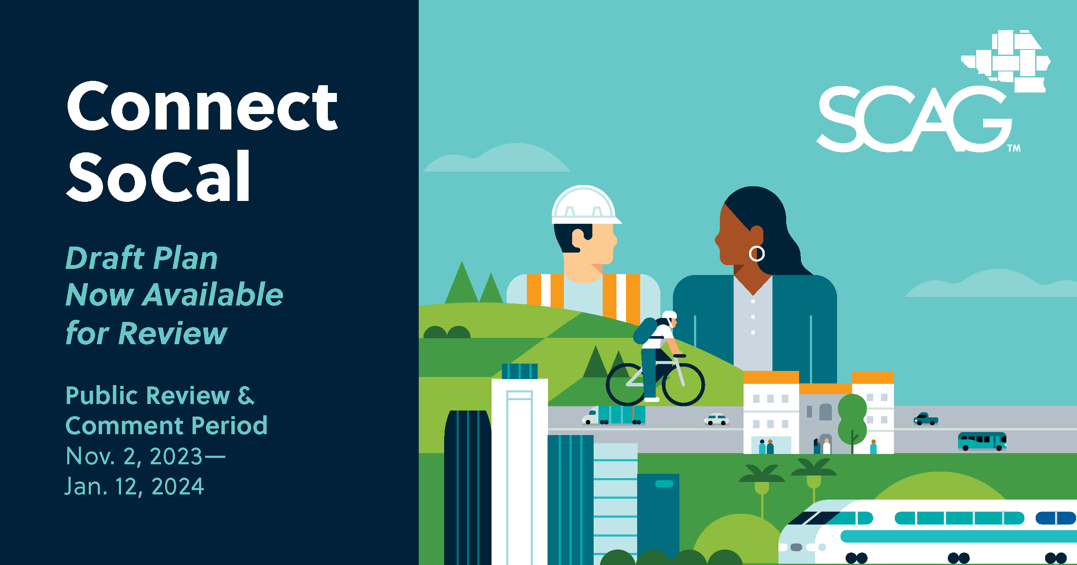 | 1200px x 630px | Dropbox: General Landscape Graphic
Additional Sizes | See graphics folder for additional sizes. | Various sizes | Dropbox: Connect SoCal Toolkit Graphics

